**INFM 600 – Project Summary**

**Dataset and Source:**

Kaggle is an online platform to compete with others in competitions which are based on data sources, datasets, data manipulation over machine learning tasks. The dataset we derived from Kaggle presents Annual Developer Survey results for the Stack Overflow Users (developer community) getting specifics about their background, skillsets, knowledgebase, technology expertise, job satisfaction/expectations and income statistics. The dataset has 129 columns and 98,855 rows of qualitative data about the developers.

**Target Audience:**

For our project, our target audience are decision makers at companies, such as CEOs, hiring managers, or investors. The types of companies that we are targeting are mostly tech companies or any company in need of coders or are looking to hire out of the country workers.

**Results, Interpretations, and Recommendations:**

* **Question:** Job satisfaction comes with more salary compensations/expectations?
* **Plot:** 
* **Results:** The correlation test determined that there is no correlation between job satisfaction and salary being made
* **Interpretation:** This means that making a lot of money can make individuals happy in their job. There are other factors that may affect how satisfied a person is in their job such as position, workload, and benefits.
* **Recommendation:** Instead of just offering more and more money to workers, companies, can focus on other factors such as giving workers longer breaks, having work activities, or having celebrations and awards for employee and company accomplishments.
* **Question:** Is there a correlation between years coding professionally and job satisfaction?
* **Plot:**



* **Results:** Correlation Test determined that there is no correlation job satisfaction and the number of years a person has been coding professionally.
* **Recommendation:** This means that just because an individual has been coding professionally for a long time, it doesn’t mean that they are more likely to be satisfied with their jobs. For hiring managers this might mean, not putting too much emphasis on years coding professionally (except for experience purposes), when looking for worker that will fit in and be satisfied in the company.
* **Question:** Which country has the most skilled coders?
* **Plot:** 
* **Results:** Granada and Saint Lucia are the top locations with a n average of 33 Languages known
* **Recommendation:** Based on the results, is a company is planning to offshore their work, it might be better to hire people in Granada or Saint Lucia. (Does not factor labor cost)
* **Question:** Does the number of years in a job affect the workers’ willingness to switch?
* **Plot:**
* **Results:** Correlation Test determined a positive moderate correlation between the attributes. (.397) This means that as the number of years of coding professionally increases, the probability of switching decreases
* **Recommendation:** For companies trying to retain their employees, during the hiring process it would be better to take an applicant who has been coding professionally longer since he or she will be less likely to quit and switch jobs.
* **Question:** Does a person’s age affect their willingness to switch jobs?
* **Plot:**

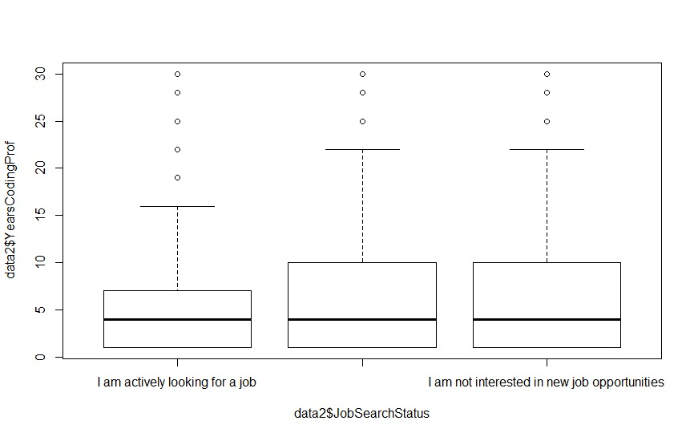

* **Results:** There is moderate correlation between age and willingness to switch jobs. This means that as age increases, the probability of a person switching their job gets lower.
* **Recommendation:** For companies this means that their older employees are less likely to leave their jobs. This may mean focusing more employee retention efforts for the younger employees who are more likely to leave.
* **Question:** Do people use sites like stack overflow to find new jobs?
* **Plot:**



* **Results:** 38727 users said yes, and they use the site to find jobs.
* **Recommendation:** Companies looking to hire coders can take advantage of the job listings on Stack Overflow and view some of the projects that the coders looking for jobs had worked on.

**WORD COUNT:** 598